Results and Comments: Group 5
Question 1
The dataset contains 3,138 firm-level observations and 5 variables (sector, ys, w, k, n). Firms are distributed across four sectors: sector 4 is the largest group (1,652 firms, 52.64%), followed by sector 1 (788, 25.11%), sector 3 (488, 15.55%), and sector 2 (210, 6.69%).
Overall, log relative wages (w) have mean 3.499 and standard deviation 1.518, while log capital (k) has mean close to zero (0.005) and standard deviation 2.025. Log employment (n) shows substantial dispersion (mean 16.877, sd 29.816) with very large negative and positive values, suggesting the presence of extreme observations in log employment. Across sectors mean log output is 4.639 with a standard deviation of 1.315.
Comparing sectors, average log relativewages are very similar across sectors (means around 3.471–3.54). Log capital dispersion is comparable across sectors as well (means around -0.129 to 0.105), while log employment (n) remains highly variable in each sector, with particularly large ranges driven by extreme values (sector 2 report a mean log employment of 2.84 while sector 4 does of 25.787). log sector output ranges from a mean of 1.516 in sector 2 to 5.717 in sector 4.
Pairwise correlations among the main variables are generally small in magnitude: n is negatively correlated with w (about -0.055) and positively correlated with k (about 0.058) and ys (0.3111).
Question 2
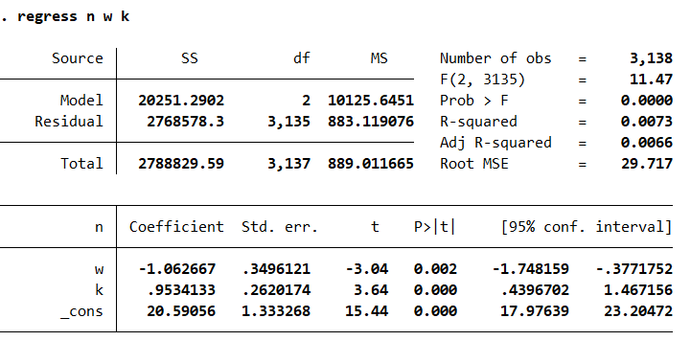
The estimated coefficient on wages is -1.06 while the estimated coefficient on physical capital is 0.953. The regression explains a very small fraction of the variation in employment (R^2 = 0.0073).
Question 3
We use individual t-tests with null H0: $β_{1}=0$ and H0: $β_{2}=0$, and we observe that on relative wage (w) the null is rejected at conventional significance levels, so the coefficient on w is statistically significant and negative, indicating that higher relative wages are associated with lower employment (holding capital constant) (a 1% increase in relative wage is associated with a decrease in employment by 1.063% on average). The null for physical capital (k) is rejected at conventional significance levels, so the coefficient on k is positive and significant, indicating that capital is associated with higher employment, holding the other regressor constant (a 1% increase in capital is associated with an increase in employment by 0.953% on average).
Question 4
We test whether the relationship estimated between employment (n) and the regressors (w, k) is the same one across sectors: we make four tests:
- First we check whether firms in different sectors have systematically different average employment levels after controlling for wages and capital (the null is homogeneity across sectors in intercepts) together with whether the effects of wages and capital on employment are the same in every sector (i.e. the slopes of these variables differ)the joint F-test that all sector dummies are zero and all interactions between these dummies and log relative wages and log capital are zero as well, rejects this null (F(9, 3126)=46.98, p=0.0000)
Next we try to isolate whether it is the intercepts or slopes driving this effect:
- We check whether firms in different sectors have systematically different average employment levels after controlling for wages and capital (the null is homogeneity across sectors in intercepts) The joint F-test that all sector dummies are zero rejects the null (F(3,3132)=125.88, p=0.0000), indicating evidence of sector-specific intercept differences once wages and capital are controlled for.
- We check whether the effects of wages and capital on employment are the same in every sector (not just the average level, and here the null is all interaction terms are zero, i.e. wage and capital slopes do not differ by sector.) To test whether the effects of wages and capital differ across sectors, we estimate a model with sector interactions for both regressors and perform a joint F-test that all interaction terms are zero (i.e., sector-specific slope differences are absent). The null of homogeneous slopes across sectors can be rejected (F(6,3132) =6.83, p=0.0000), indicating evidence that the wage–employment or capital–employment relationship varies by sector.
- Instead of using four dummies, we use ys as a sector-level regressor to capture systematic sector differences through one variable (here the null is that no sectoral heterogeneity is captured by ys) As an alternative sector-level homogeneity check, we include sectoral output $ys$ in the baseline regression and test whether its coefficient is zero. The null that $ys$has no effect can be rejected (t = 18.40, p = 0.0000), indicating evidence that sectoral output shifts employment once wages and capital are controlled for.
Question 5
Given the evidence of sectoral heterogeneity, I accommodate it by estimating a specification with sector fixed effects and sector-specific slopes for both wages and capital. Concretely, I include sector indicators and interact $w$ and $k$with the sector dummies, allowing both the intercept and the wage/capital effects to differ across sectors.
Question 6
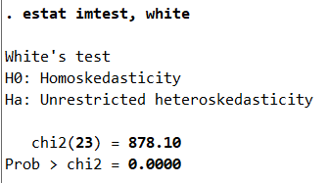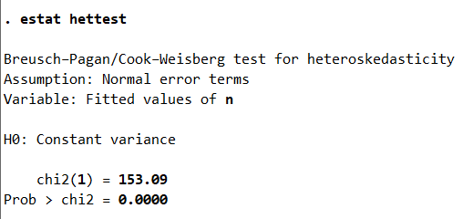
Both tests strongly reject the null of conditional homoskedasticity (p-values are essentially zero), so there is clear evidence of heteroskedasticity in the error term. Therefore, inference based on conventional OLS standard errors may be unreliable.
Question 7
Given evidence of heteroskedasticity, I re-estimate the preferred sector-heterogeneous model using heteroskedasticity-robust (White) standard errors. The point estimates are unchanged relative to OLS, but the standard errors (and hence t-statistics and p-values) are computed robustly. In the robust specification, most sector–slope interaction terms are not individually significant, while sector 2 shows a statistically significant intercept difference relative to the baseline sector.

